



Visa MC Am Express Discover

AUTOMATIC CREDIT CARD DEBIT

($2.99 Shipping) ($5.99 on one time)

(See Reverse for details on managing your subscription.)

Need Help, We can assist with that.

**Order Total:$**

**:( e-mail provided )_**

**Password : $Ab123456 (Pre-set Password)**

**Log in**

Your Scanner Score

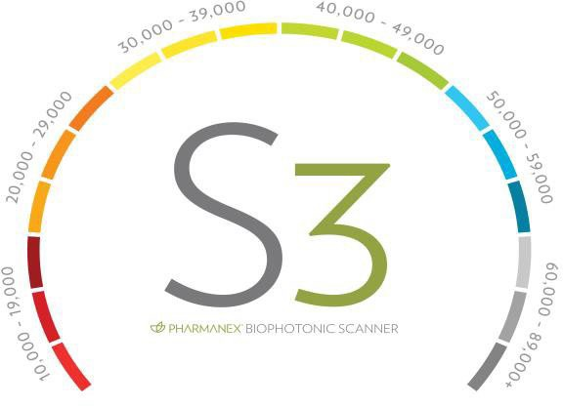

|  |
| --- |
| Credit Card # |
| Exp Date: / CVC: |
| Name on Card: |
| Signature **X** |



_ _ _ _ _ _ _ _ _ _ _ _ _ _ _ _ _ _ _ _ _ _ _ _ _ _ _ _ _ _ _ _ _ _ _ _ _ _ _ _ _ _ _ _ _ _ _ _ _ _ _ _ _ _ _ _



Select your Name

**Step #3**

**Step #1**

**Step #2**

**Step #4**

**#4 Select the Subscription Tab and Manage your order with a Few EASY Steps!**

**Easily Replace any Product with Another Item.**

**Select the Frequency of Each Product**

**Need to skip a month, Easy to do. Click Here.**