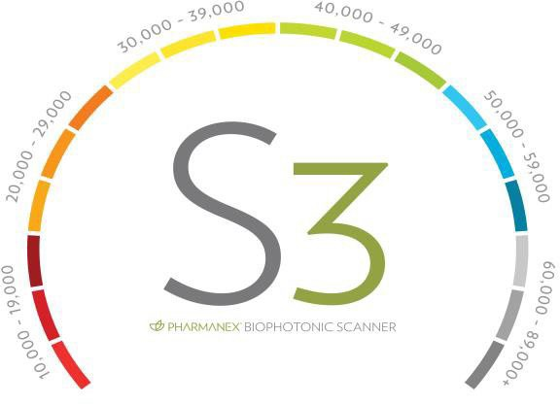



ORDER FORM

DATE

FIRST LAST PHONE ( )

ADDRESS

EMAIL @

CITY STATE ZIP

**Scan Card #**

Billing Address

Ship to Address

ADDRESS CITY STATE ZIP _

Prioritize Prevention

**.mynuskin.com**

**Website**

**:**

Inset name here

Customer Service 800-487-1000

Pause your order / Skip a month / Switch to a Bi-monthly program

**We will set your account up for You with the information provided.**

Your Scanner Score

**Log in**

**:( e-mail provided )_**

**Password : $Ab123456 (Pre-set Password)**

($2.99 Shipping) ($5.99 on one time)

**Order Total:$**

**Initial Scan Date:**

**Re-Scan Date:**

(See Reverse for details on managing your subscription.)

A MeAsurAble nuMber thAt MAtters

Need Help, We can assist with that.

V4 5.5.23

Code

Items

Retail

**Member One Time**

**Member Subscription**

**Monthly**

**Bi-Monthly**

Quantity/Notes

Your Scanner Score

Foundational Packages and Key Products

01003680

LifePak

$99

$79

$79

01103930

LifePak & R2 Day (Vitality)

$186

$146

$136

01010273

LifePak + Youth

$253

$242

$185

01010475

LifePak + R2 Day +Youth

$320

$260

$248

01003763

ageLOC Youth

$204

$163

$109

01130314

ageLOC R2 Day (Vitality)

$83.50

$67

$60

01002502

ageLOC R2 Day & R2 Night

$176

$135

$125

01003610

LifePak Nano *

$196

$174

$163

**\*#01010001 –G3included**

AUTOMATIC CREDIT CARD DEBIT

**Gut Health**

01130120

NuBiome

$69

$59

$49

Visa MC Am Express Discover

01001929

ageLOC Meta

$158

$126

$99

01130155

ageLoc Meta & Nu Biome *

$227

$185

$130

**\* Subscription code listed**

Credit Card #

01003520

ProBio PCC

$50

$41

$37

01002582

Nu Ease

$40

$30

$25

**Eye Care**

Exp. Date:

01003747

Eye Formula

$55

$44

$39

CVC Code:

01003536

Marine Omega

$77

$61

$61

Name on Card:

01003103

Optimum Omega

$24

$20

$20

**Additional Subscription Packages**

Cardholders Signature:

X

01003519

**Reishimax - Ultimate ImmuneSupport**

$123

$98

$88

01003516

Night Time Formula

$36

$29

$29

01002344

Collagen Beauty Focus- Peach

$158

$126

$99

I would like to receive my products automatically every month. I have indicated the quantities, processing date, and payment methods

01002654

Collagen Beauty Focus

$158

$126

$99

01003930

E2 Kiwi Watermelon/ Rasberry

$52

$42

$42

**FOR THE KIDS**

01001956

**Jungamals - Your Lifepak for Kids**

$41

$33

$33

01003079

**Mighty Minds-**Omega-3 Fatty Acids EPA DHA

$41

$33

$33

**TOTAL**

**Plus $5.99 shipping (subscription orders $2.99)**

For Office User Only Place orders at

Clinic ID : #US

Order Placed Phone Support: *800-487-1000*

Rep Contact: ( *)- -*

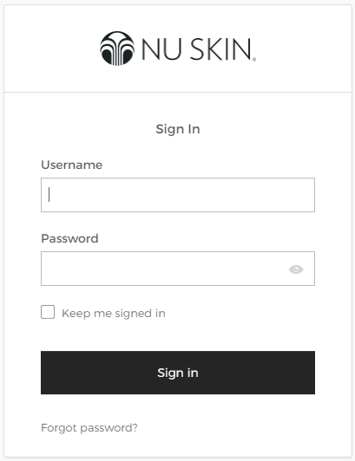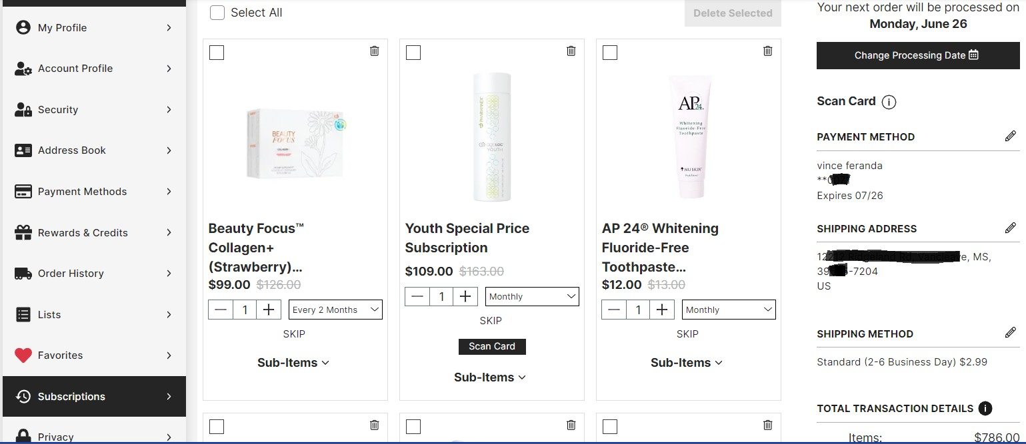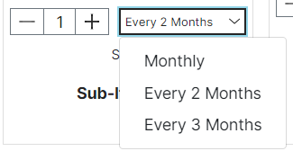

**To Make Changes to Your Account Visit :**

**Step #1**

**Step #2**

Your Email

$Ab123456

**Ea**

**w**

**t**

Select your

Name

.

**Select the Frequency of Each Product**

**Need to skip a month,**

**Easy to do. Click Here.**

**Step #3**

**sily Replace any Produc ith Another Item.**

**#4 Select the Subscription Tab and Manage your order with a Few EASY Steps!**

**Step #4**