





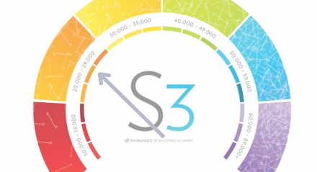

Scan the Item You Want

**Select your Nutrition Protocol**

**Setting up your package is Easy**

**Options tailored to your budget and health goals**

**How it Works:**

1. Scan QR code
2. Setup your account*

*\*Free to join*

*\*No monthly minimum purchase required*

Monthly Bimonthly

Trimonthly Options

Easy to: Pause/Skip/Switch Products

Cancel anytime



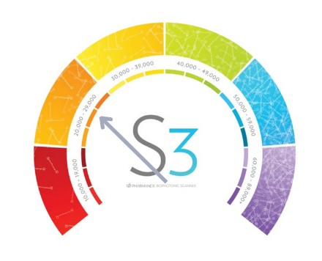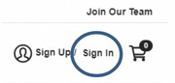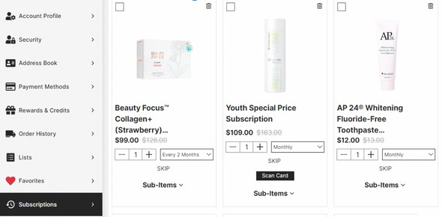

**Manage**

**Your Account**

Make changes to your account by using the following login:

Recommended by Physicians

**Username: your email**

**Password: $Ab123456**

**How to Edit a Subscription**

This may be the most important number you get for you and your family.

**Use username & password above to sign in:**

Your score:

Step 1

**Click "Subscriptions" to make any changes to the type of product or the frequency of shipment.**

Step 2

***NSF Certified, PDR Listed Supplement Line***

**Scan here to visit website**

***Measure the difference. Once subscribed, get a rescan every 30-60 days.***